Pokhara University

Level: Bachelor | Semester – Spring | Year : 2006
Programme: BE |  | Full Marks: 100
Course: Digital Communication |  | Time : 3hrs.

Candidates are required to give their answers in their own words as far as practicable.
The figures in the margin indicate full marks.

Attempt all the questions.

 | - State and prove Nyquist sampling theorem for band limited signal. Also explain the effect of under-sampling.  - Showing the typical Pulse Code Modulation (PCM) system, prove that the maximum signal to quantization noise power ratio (SQNR) for PCM is equal to 4.8 + 6n dB. Where n represents the number of bits required to represent a sample. | 8  7
 | - What do you mean by Time division multiplexing? Explain the T1 PCM system.  - Define information, self-information and entropy. Find the self-information and entropy of the source S={s₁, s₂, s₃, s₄}, the probability of occurrence of each symbols are P(s₁) = P(s₂) = P(s₃) = P(s₄) = 0.25. | 8  7
 | - What is inter-symbol interference (ISI)? Derive the Nyquist condition for zero ISI?  - Represent the binary data1010111010000010100001 by the following base band representation formats:  - Polar format  - Bipolar / pseudoternary /AMI format  - Manchester format  - HDB3 signaling | 7  8
 | - A rectangular pulse 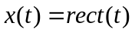 is passed through an ideal low-pass filter of bandwidth B. The amplitude response of filter is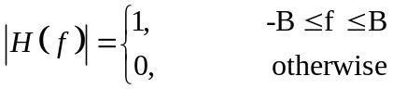. Find the power spectral density of the filter output y (t).  - Showing signal space diagram, derive the expression for average probability of symbol error for coherent Binary Phase Shift Keying (BPSK). | 8  7
 | - Calculate the noise equivalent bandwidth of an RC network as shown in figure below.  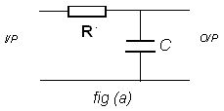  - Define the terms channel signal to noise ratio (SNR)_{C} , output signal to noise ratio (SNR)_{O} and figure of merit (FOM). Derive an expression for the figure of merit for an AM (DSB-AM) receiver using synchronous detector. | 8  7
 | - Explain the threshold effect in AM and FM.  - Differentiate between block code and convolution code. What is constraint length in case of convolution code? Explain with suitable example. | 8  7
 | Write short notes on (Any Two):  - Granular noise and slope overload noise in delta modulation  - Pre-emphasis and De-emphasis  - Ergodic process. | 2×5

